**THE GREAT LIBRARY**

* **ABSTRACT**

‘**The Great Library**’ is nothing but a group of people which require to manage the libraries of schools and colleges. Library management System is a project which aims in developing a computerized system to maintain all the daily work of Library. Library is a collection of organized information and resources which is made accessible to all user for borrow and take references from that. This project has many features which are generally not available in normal library management system. In this project there is college library management system where students can easily get to know about the book available in library, also staff and student of library get to know the books statuses also they will get to know from which publisher the book has been publish. The book status which has been borrowed by student. So from this we can easily manage our library system and also from this data will properly store and up-to-date.

* **Objective and aims of project**

1. Can create a computerized system for easily management.
2. Has the capability for issue books.
3. Can manage student through main administrator account.
4. Can store all the book and students data in a proper manner.
5. Tracks the book that users have issued and returned.

**STRUCTURES OF TABLES**

1) BOOKS

This tables contains the complete details of all the books which is available in library also from which publisher the book has been published.

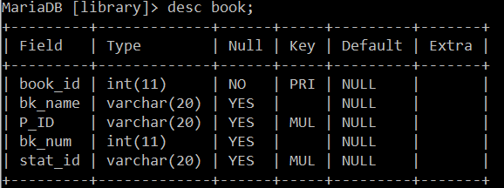

2) STUDENTS

This tables contains all the details regarding student and their library card.

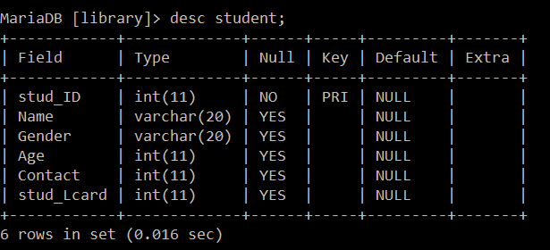

3) Publisher

This tables has complete detail of the publisher from where the book has been published to library.

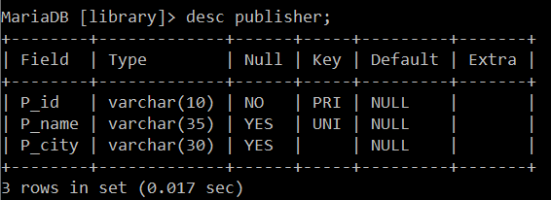

4) Status

From this table we get to know the statuses of the books that has been issued and returned.

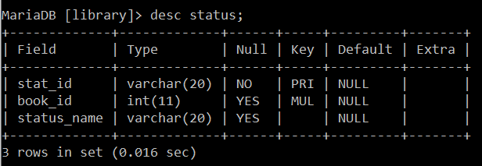

5) Borrow

This table show the complete details of the book which has been borrowed by the students (the date of borrow and return).

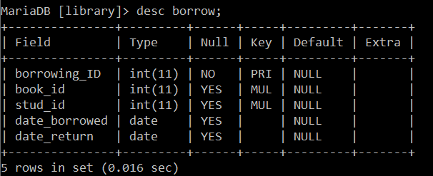

**CONTENTS OF TABLES**

1) BOOKS

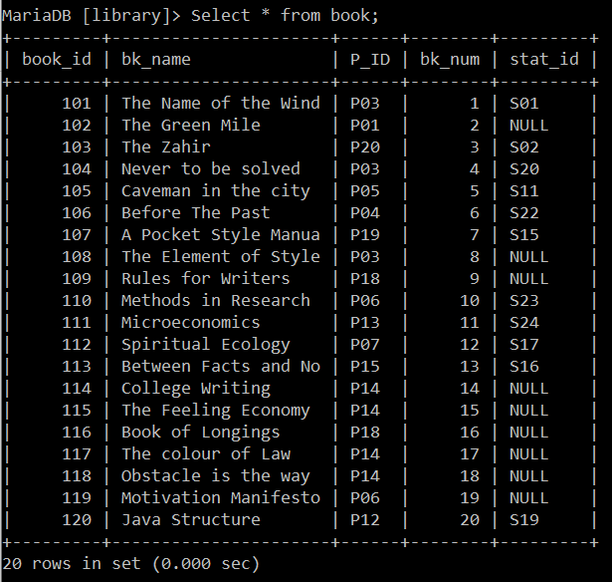

2) STUDENTS

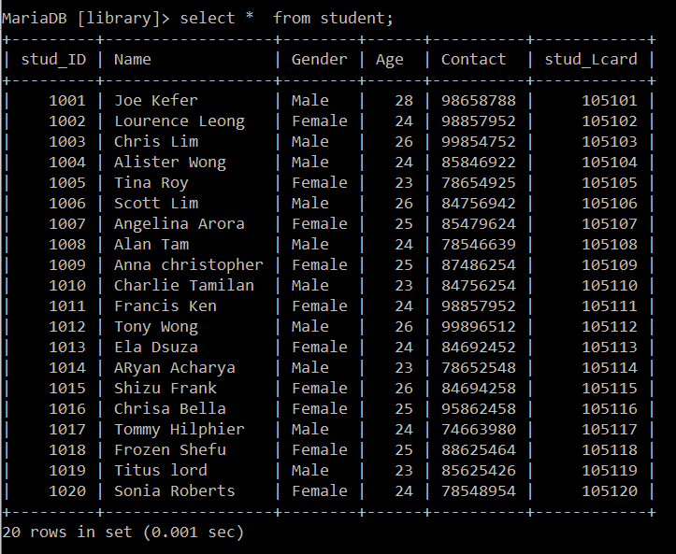

3) Publisher

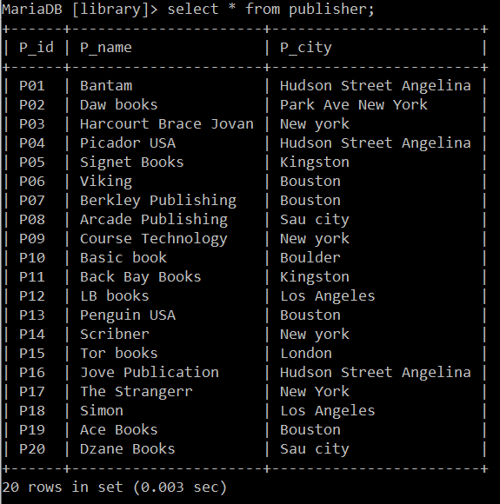

4) Status

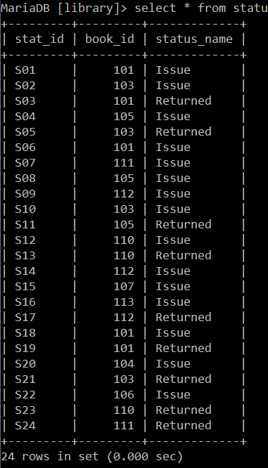

5) Borrow

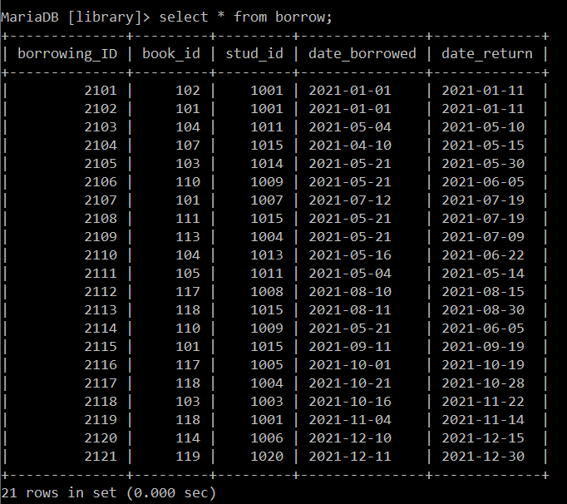

**SUBQUERIES**

1) Display all the Student Id who has Issues the book from college Library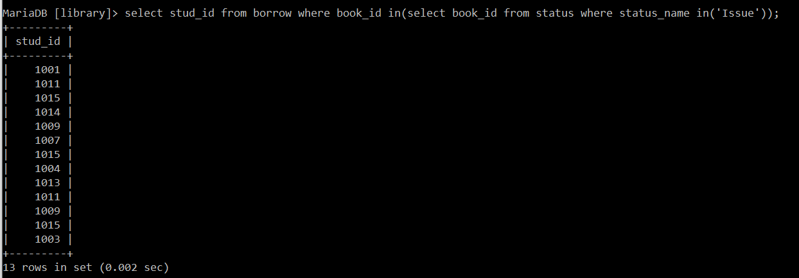

2) Show the complete data of the Student who has Issue and Returned their books from the library.

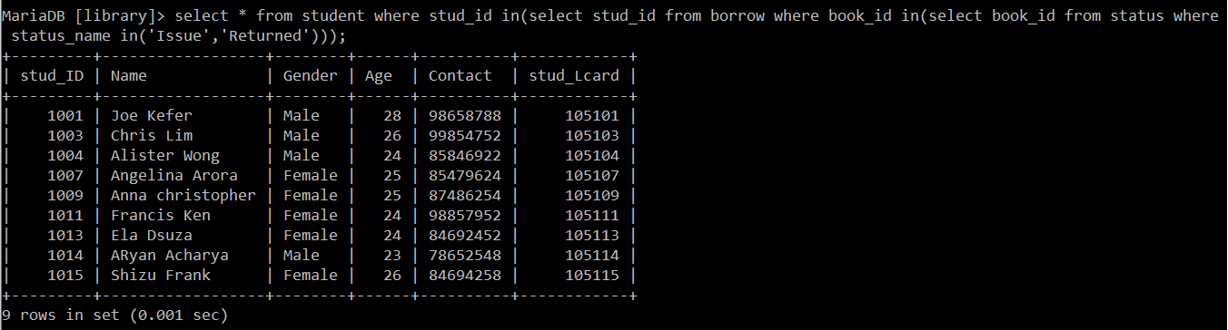

3) Find out or display out the details of the publisher whose book has present in our library.

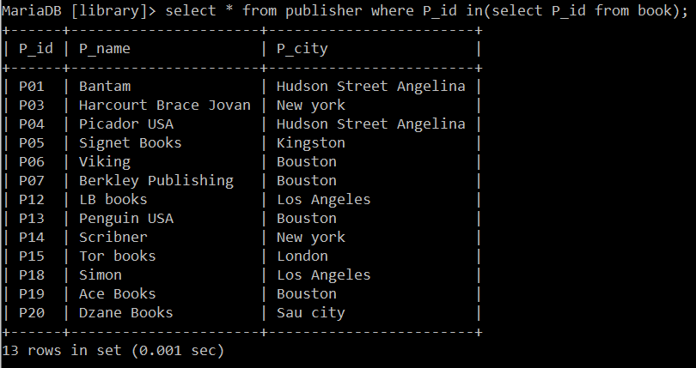

**VIEWS**

1) Create a view and display out a view considering the details of those books which had never issue or taken by the student.

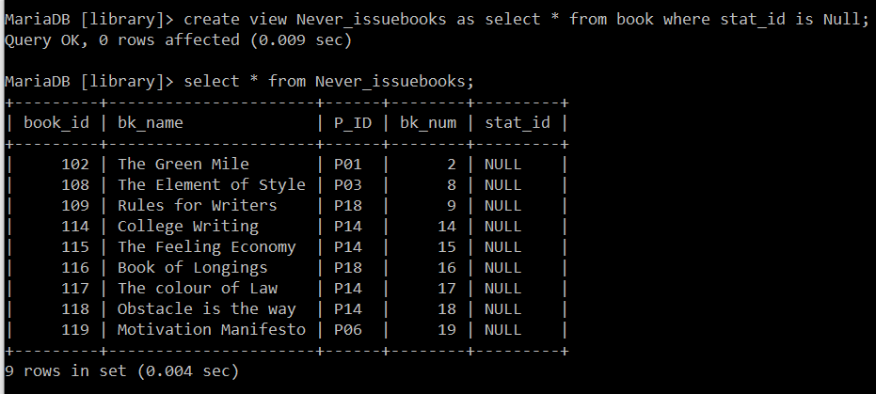

2) Create a view for the books which has been borrowed on 2021-05-21.

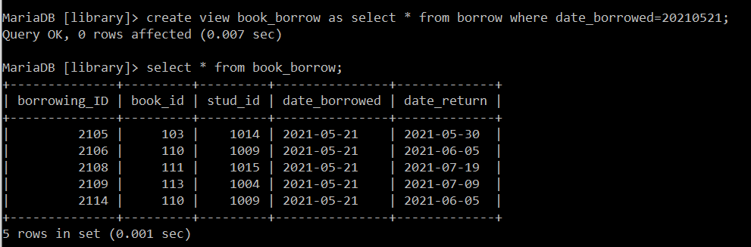

3) Create a view to find out all the details of the books which has been Publish by the Publisher ‘Scribner’.

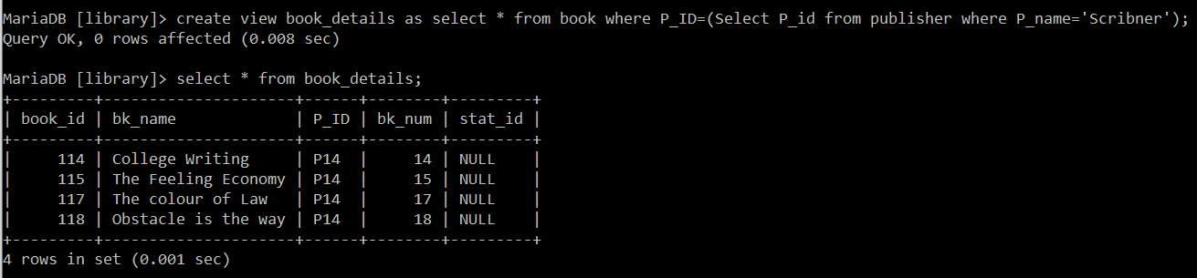

**JOINS**

1) Display all the details of the book with their statuses which has been issued and returned from the library.

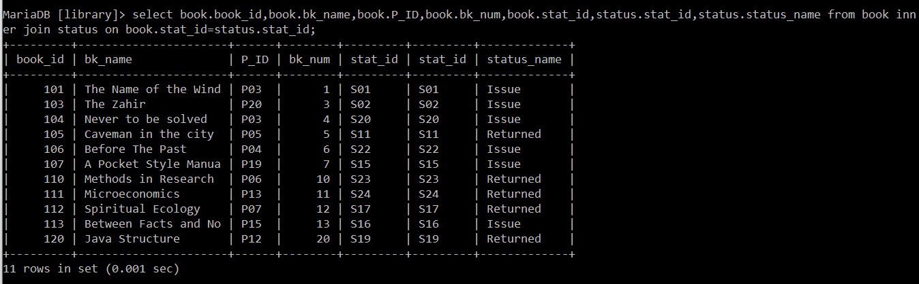

2) Show all the details of the borrowing table and student table and also sort the complete data ascendingly.

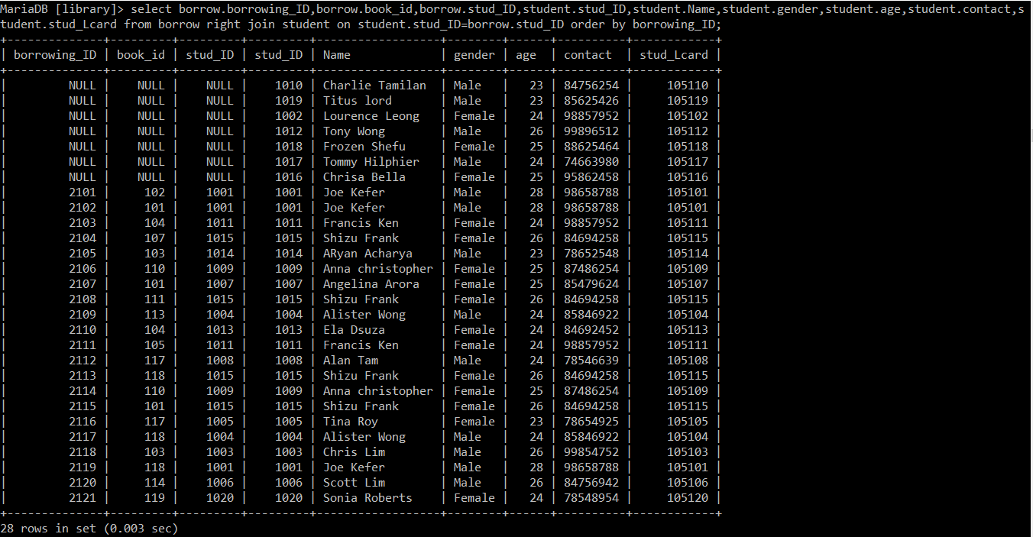

3) Display the details of the students with borrowing details and their statuses with respect to the stud_ID’s.

